**CHAPTER 3**

*’ **PROJECTIONS OF PLANE SURFACES**

**Problem** 1 An equilateral triangular lamina of 25mm side lies with one of its edge on HP such that the surface of the lamina is inclined to HP at 60°. The edge on which it rests is inclined to VP at 60°. Draw the projections.

’’ **Solution**

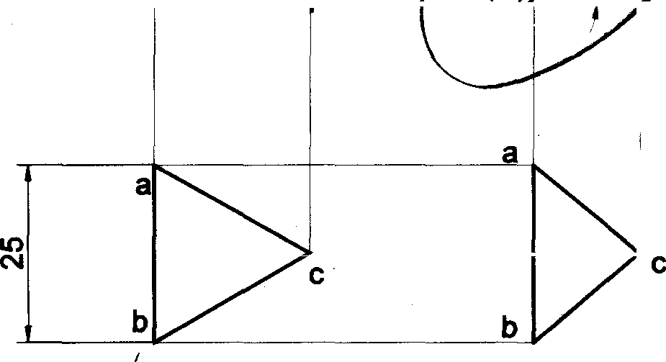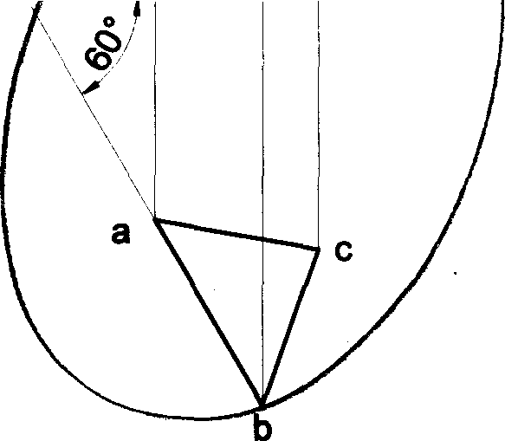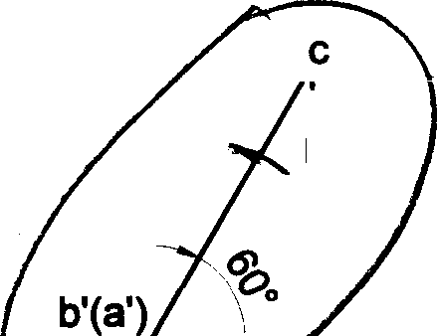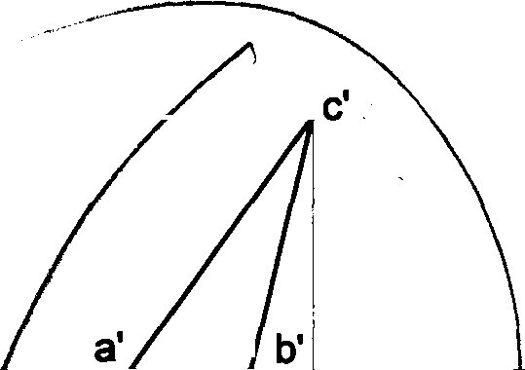

VP

HP

b’(a')

b'

**Problem** 2 An equilateral triangular lamia of 25mm side lies on one of its sides on HP. The lamina makes 45° with HP and one of its medians is inclined at 40° to VP. Draw its projections.

**Solution**

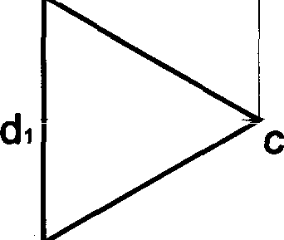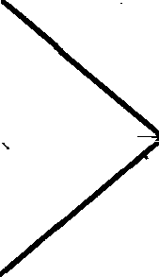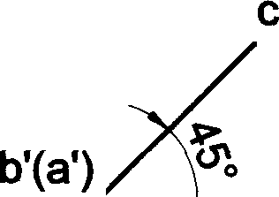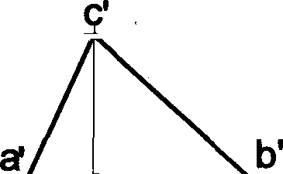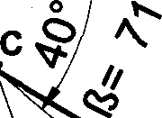

VP

HP

b’(a’)

c

o

a a

b

Locus of D

d d‹

d

b

## Y



 53 "

Problem 3 A triangular lamina of 25mm sides rests on one of its comers on VP such that the median passing through the comer on which it rests is inclined at 30° to HP and 45° to VP. Oraw its projemions.

##### Solution

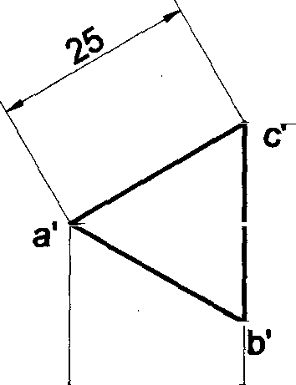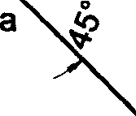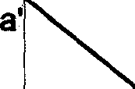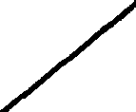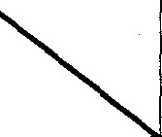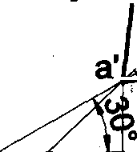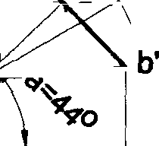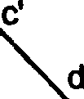

/d1’

Locus of D

d1'

d’

t b'

X

a

(bjc

VP

Y

HP

a

(b)c c b

Problem 4 A triangular plane figure of sides 25mm is resting on HP with one of its corners, such that the surface of the lamina makes an angle of 600 with HP. If the side opposite to the corner on which the lamina rests makes an angle of 30• with VP, draw the top and front views in this position.

Solution

Y

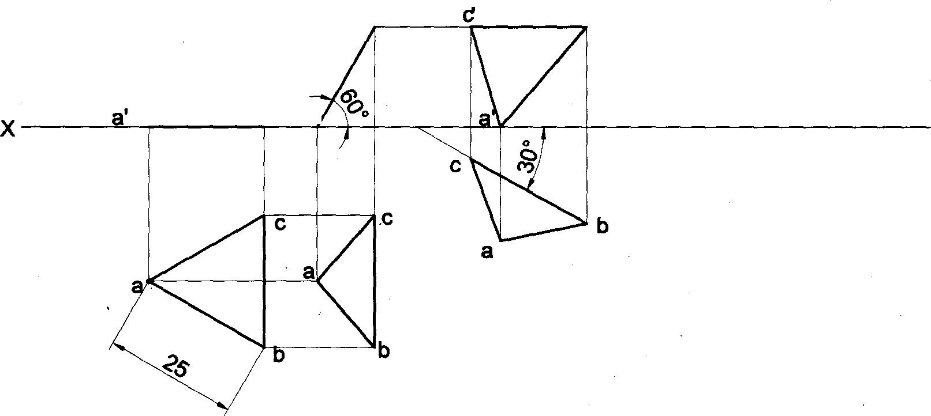

b(c)

b'

b' (c')

a'

V P

H P

Problem 5 A triangular plane lamina of sides 25mm is resting on HP with one of its comers touching it, such that the side opposite to the corner on which it rests is 15mm above HP and makes an angle of 30° with VP. Draw the top and front views in this position. Also determine the inclination of the lamina to the reference plane.

##### Solution

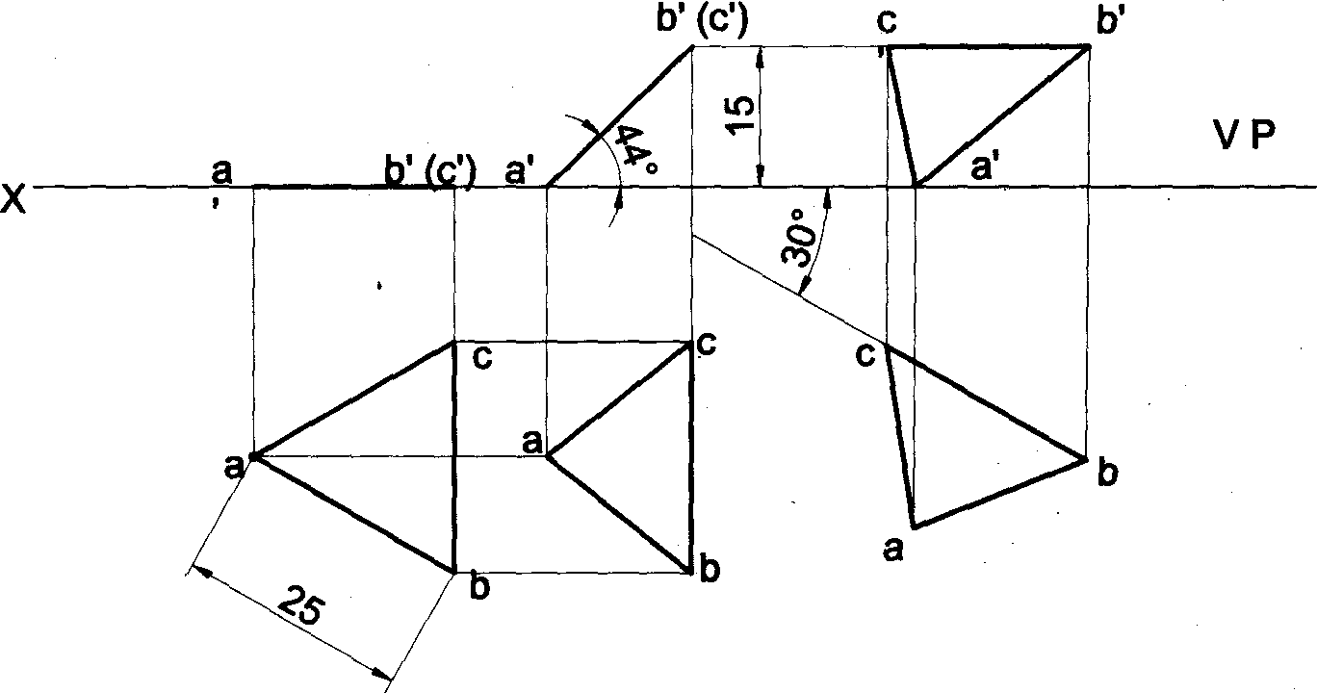

H P

54

Problem 6 A30°-60° setsquare of 60mm longest side is so kept such that the longest side is in HP, making an angle

60

of 30° with VP. The set square itself is inclined at 45° to HP. Draw the projections of the setsquare.

##### Solution

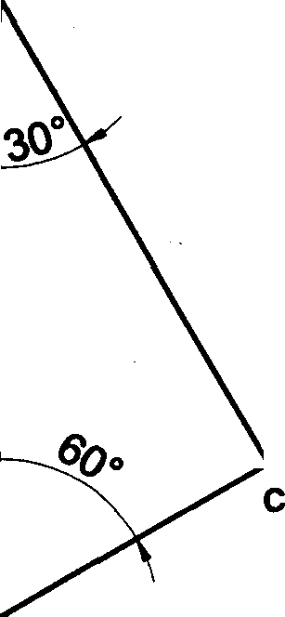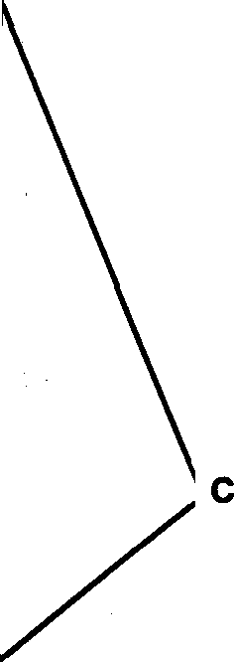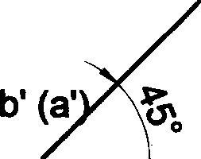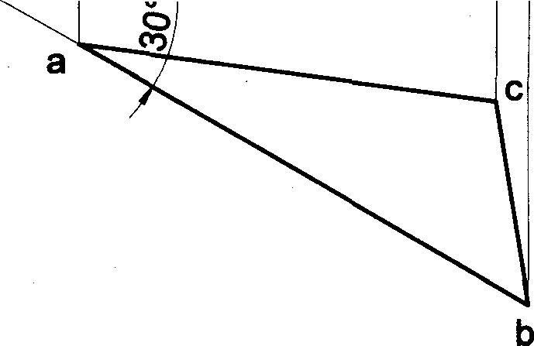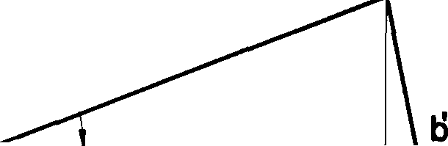

c’

b’ (@')

c'

HP

a

a

Problem 7 An isosceles triangular plate of negligible thickness has base 25mm long and altitude 35mm. It is so placed on HP such that in the front view it is seen as an equilateral triangle of 25mm sides with the side that is parallel to VP is inclined at 45° to HP. Draw its top and front views. Also determine the inclination of the plate with the reference plane.

Solution

#### y

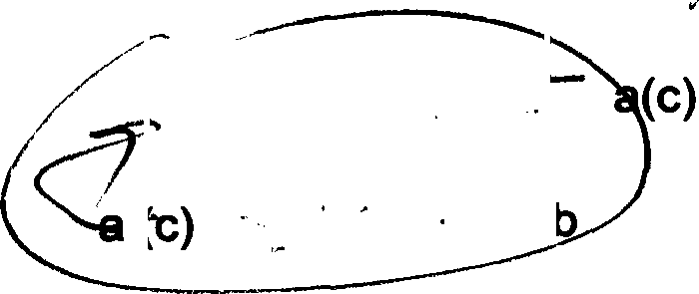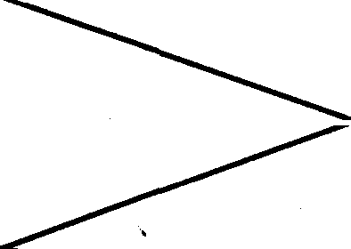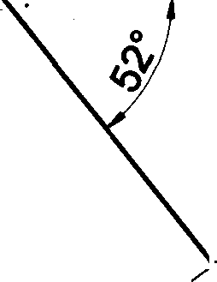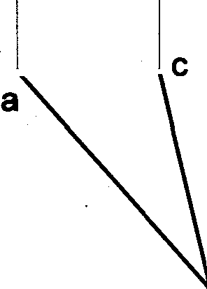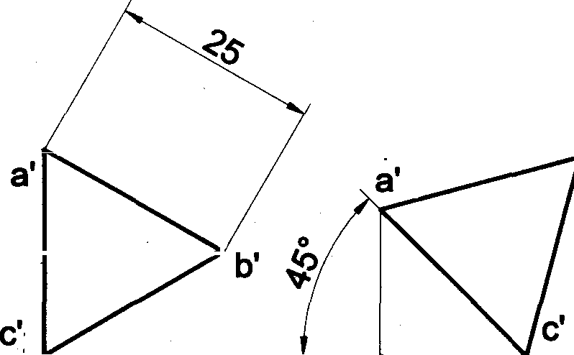

35

a'

b’

^'

VP

HP

b

b’

25



55

**Problem** 8 A square lamina of 40mm side rests on one of its sides on HP. The lamina makes 30° to HP and the side on which it rests makes 45° to VP. Draw its projections.



###### Solution

(c’) b'

b' C'

VP a' (d') HP

X

d

(c') b' a’ (d’) \o a' d’



d

d “

a a b a

b

**Problem** 9 A square plate of 30mm sides rests on HP such that one of the diagonals is inclined at 30°to HP and 45° to VP. Draw its projections.

###### Solution

I

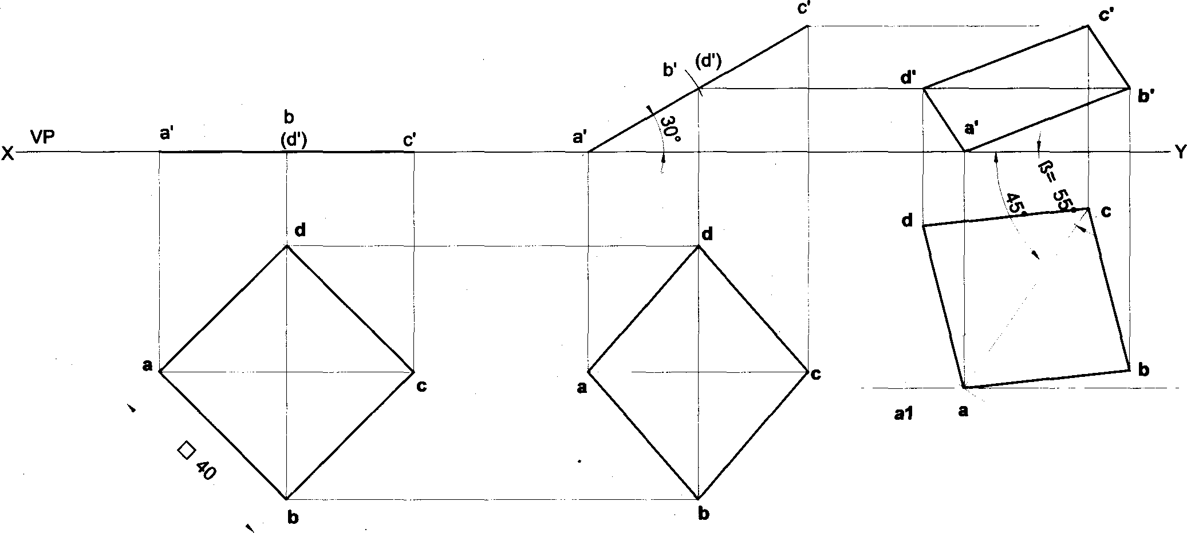

HP

Locus of A

56

Problem 10 A square lamia ABCD of 40mm side rests on corner C such that the diagonal AC appears to be at45eo VP. The two sides BC and CD containing the corner C make equal inclinations with HP. The surface of the lamina makes 30° with HP. Draw its top arrd front views.

Solution

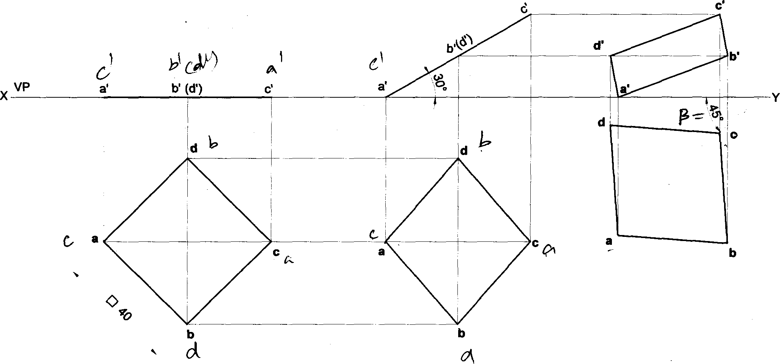

HP

Problem 11 The top view of a square lamia of side 30mm is a rectangle of sides 30mm x 20mm with the longer side of the rectangle being parallel to both HP and VP. Draw the top and front views of the square lamina. What is the inclination of the surface of the lamina with HP and VP?

Solution

RPP LSV

I

VP

X HP

a’ (d’)

d

a

b’(c')

1. d
2. a

b a 20 b

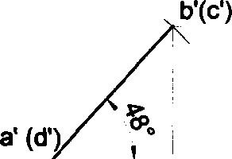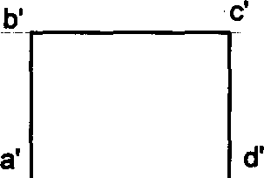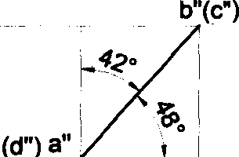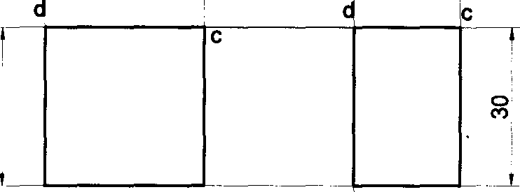

Y‹

57

Problem 12 A rectangular lamina of sides 20mm x 30mm rests on HP on one of its longer edges. The lamina is tilted about the edge on which it rests till its plane surface is inclined t HP at 45°. The edge on which it rests is inclined at 30° to VP. Draw the projections of the lamina.



Solution

X

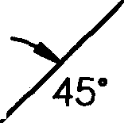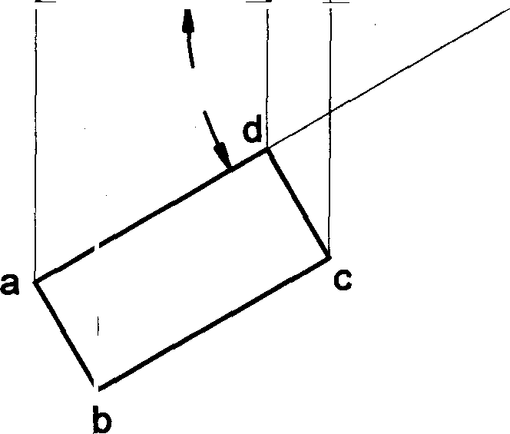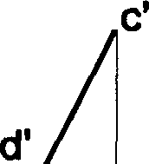

b’(c’)

b’

VP

HP

a’(d’)

b’(c’)

a’(d',

30’

d

a

b

a

b

20

d

30

**Problem 13 A** rectangular lamina of 35mm x 20mm rests on HP on one of its shorter edges. The lamina is rotated about the edge on which it rests till it appears as a square in the top view. The edge on which the lamina rests being parallel to both HP and VP. Draw its projections and find its inclinations to HP and VP.

###### Solution

Xi

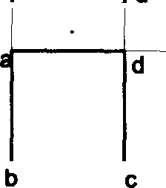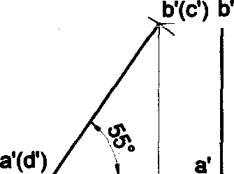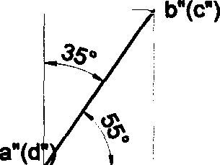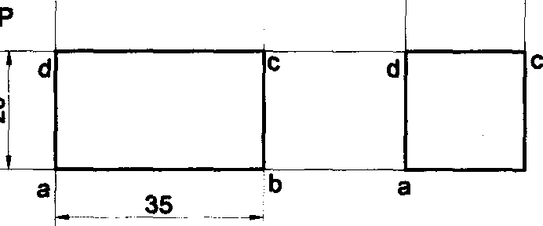

RPP LSV

VP HP

a'(d')

b'(c')

d'

d d

a

35

b

a

b

^

X Y 

58

!I

**Problem** 14 A rectangular lamina of 35mm x 20mm rests on HP on one of its shorter edges. The lamina is rotated

about the edge on which it rests till it appears as a square in the top view. The edge on which the lamina rests is inclined 30° to VP. Draw its projections and find its inclination to HP.

**Solution**

VP

X HP

20

,

a’(d') b’(c') f2’(d') Y

c d

a b

b

**Problem 15 A** rectangular lamina of sides 20mm x 25mm has an edge in HP and adjoining edge in VP, is tilted such that the front view appears as a rectangle of 20mm x 15mm. The edge, which is in VP, is 30mm from the right profile plane. (a) Draw the top view, front view and the left profile view in this position. (b) Find its inclinations with the corresponding principal planes.

###### Solution

X1

_ 15

### RPP LSV

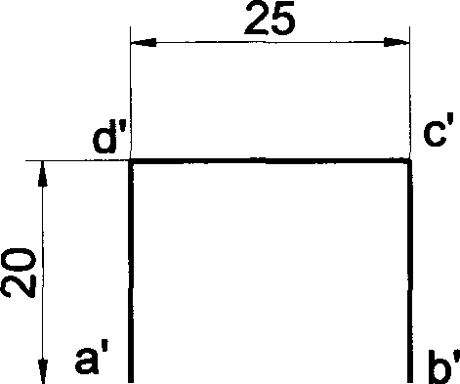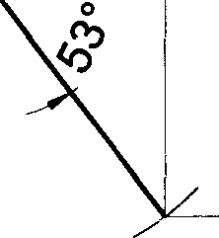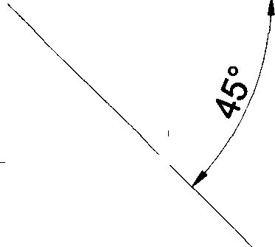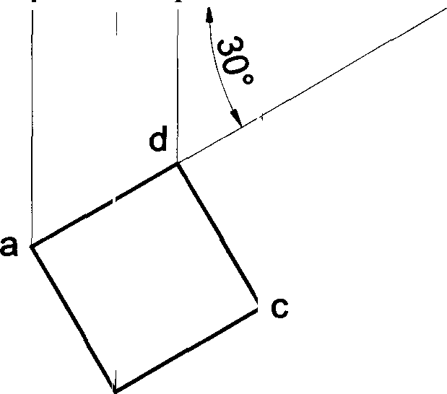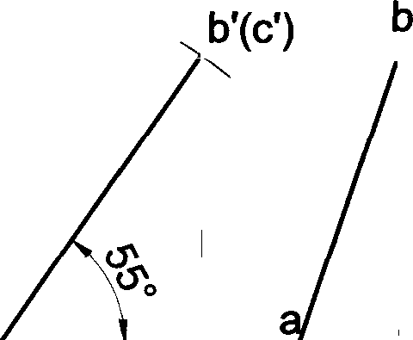

d' c’ d" C"

VP b"

a"

\ b'

20

X HP d(a) c(b)

#### 30

Y›

roaixm 1s To front view of a rectangular lamina of sides 30mm x 20mm is square of 20mm sides. Draw the projections and determine the inclinations of th6 8Urfac0 of the lamina with HP and VP.

# Solution



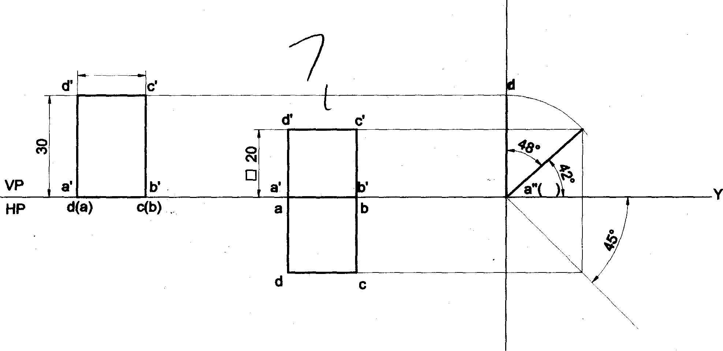

RPP LXV

20

d"(c")

b"

Y‹

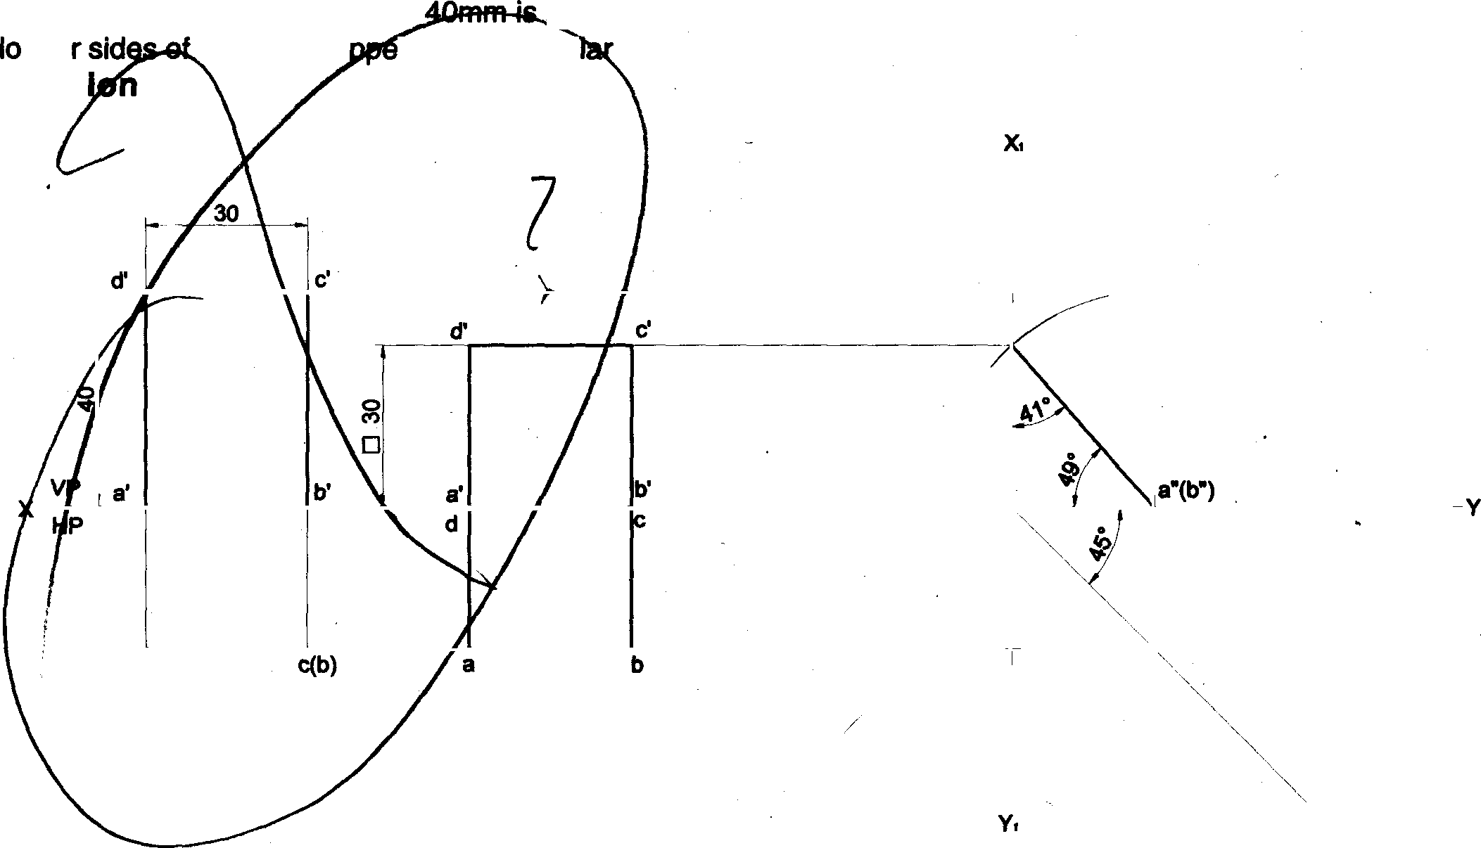

Problem 17 A mirror 30mm x

ipclined to the wall such that ils front view is a square of 30mm side. The

nge

Salut

the mirror a

àr parpendicù to both HP and VP. Find the inclination of the mirror with the wall.

RPP LSV

d•(c•)

d(a)

d•(c•)

60

Problem 18 A rectangular plate of negligible thickness of size S5x20mm has one of its shorter edges in VP with that edge inclined at 40° to HP. Draw the top view if its front view is a square of side 20mm.

Solution “

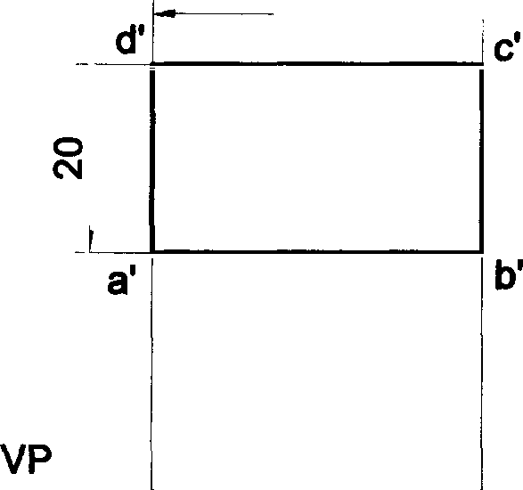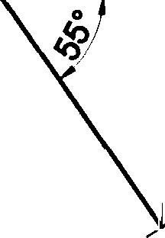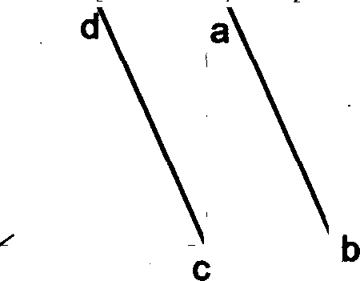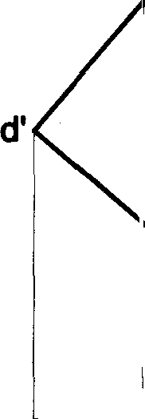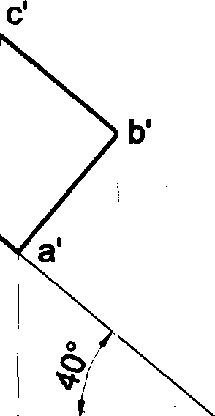

35

20

d’ ‹C'

a'

b'

x HP

d(a)

c(b)

d(a)

-Y

c(b)

Problem 19 A pentagonal lamina of edges 25mm is resting on HP with one of its sides such that the surface makes an angle of 60° with HP. The edge on which it rests is inclined at 45° to VP. Draw its projections.

Solutlon

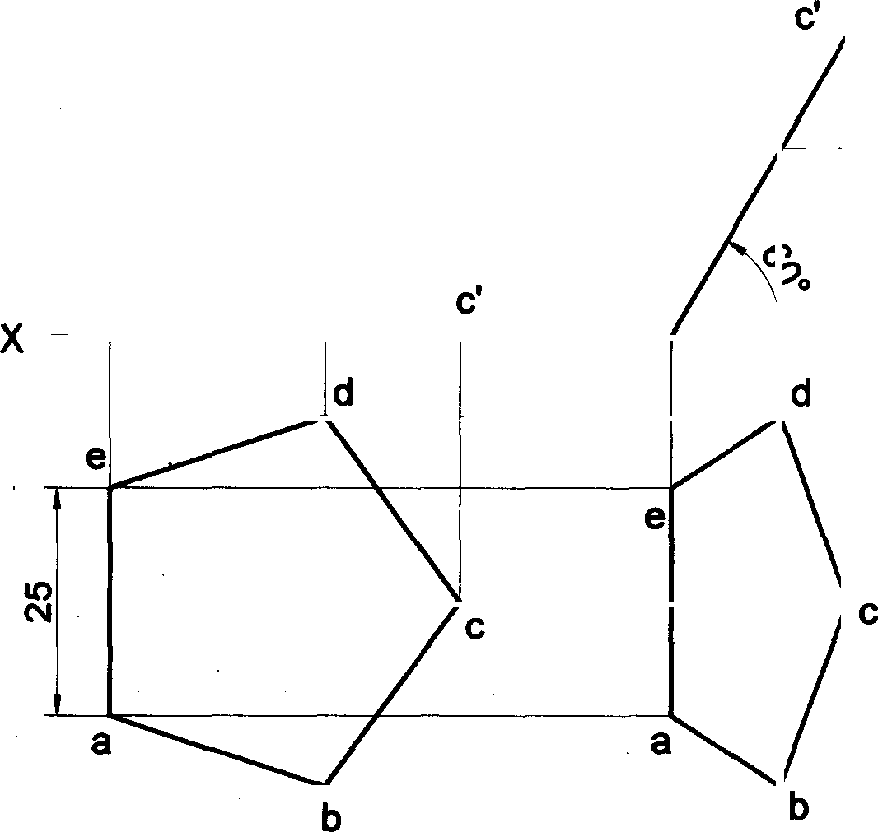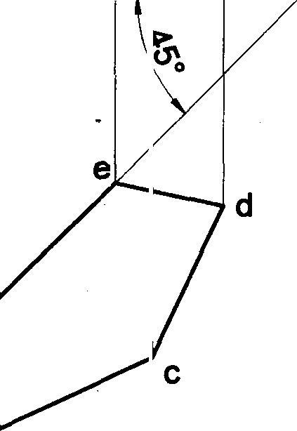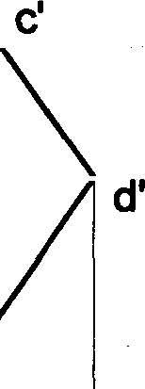

b’(d’)

a'(e’)

b'(d')

a'(e')

a'

VP

HP

a

e'

b

61

Problem 20 A pentagonal lamina of edges 25mm is resting on HP with one of its corners such that the plana surface makes an angle of 60° with HP. The two of the edges containing the corner on which the lamia rests make equal inclinations with HP. When the edge opposite to this corner make an angle of 450 with VP and nearer to the observer,

draw the top and front views of the plane lamina in this position.

## Solution



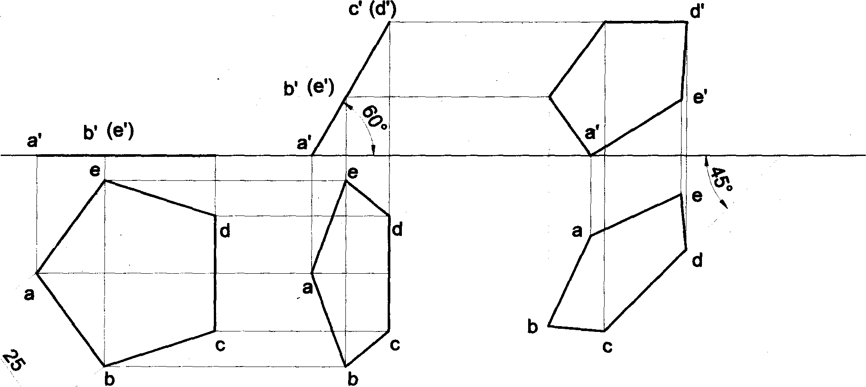

c’

b’

J(d)

VP

HP

Problem 21 A pentagonal lamina of edges 25mm is resting on HP with one of its corners such that the edge opposite to this corner is 20mm above HP & makes an angle of 45° with VP. Draw the top and front views of the plane lamina in this position. Determine the inclination of the lamina with HP.

##### Solution

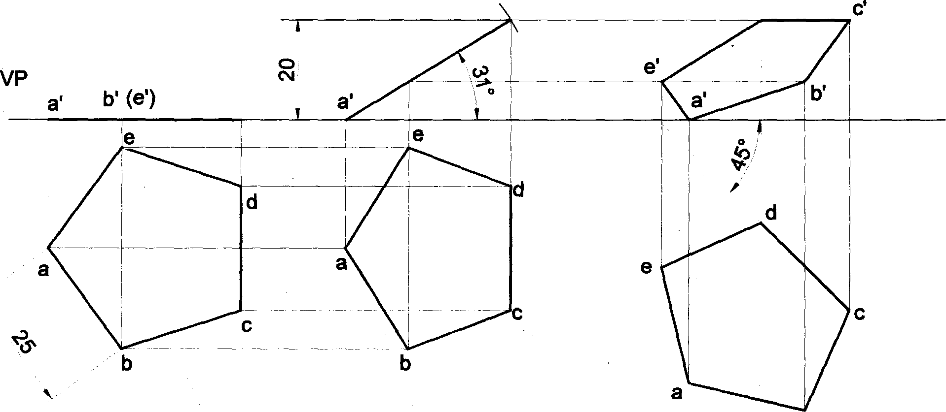

c'(d’)

d’

b(e')

c' (d’)

b



Problem 22 A pentagonal lamina of sides 25mm is resting on one of its edges on HP with the corner opposite to that edge touching VP. This edge is parallel to VP and the corner, which touches VP, is at a height of 15mm above HP. Draw the projections of the lamina and determine the inclinations of the lamina with HP and VP and the distance at which the parallel edge lies from VP.

##### Solution

c’ J

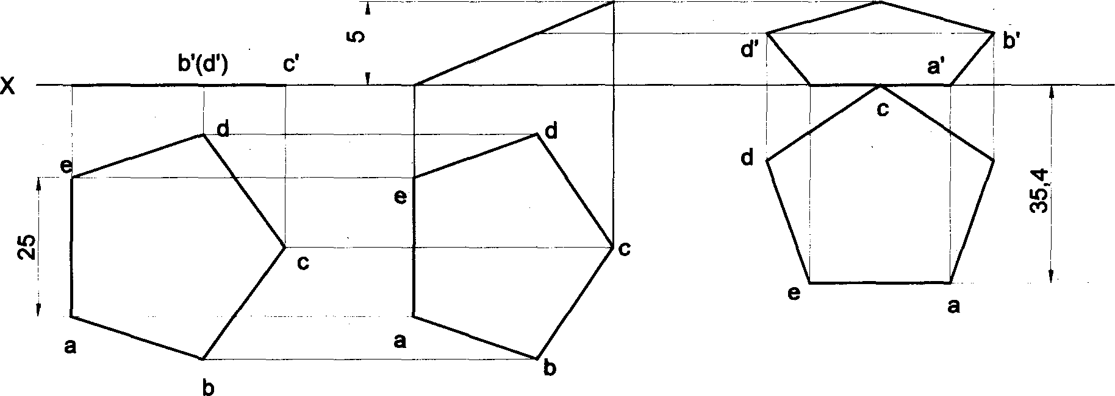

b’(d')

a'(e’)

a'(e’)

e'

VP

HP

b m

Y

Problem 23 A pentagonal lamina having edges 25mm is placed on one of its corners on HP such that the perpen- dicular bisector of the edge passing through the corner on which the lamina rests is inclined at 300 to HP and 45° VP. Draw the top and front views of the lamina.

##### Solution

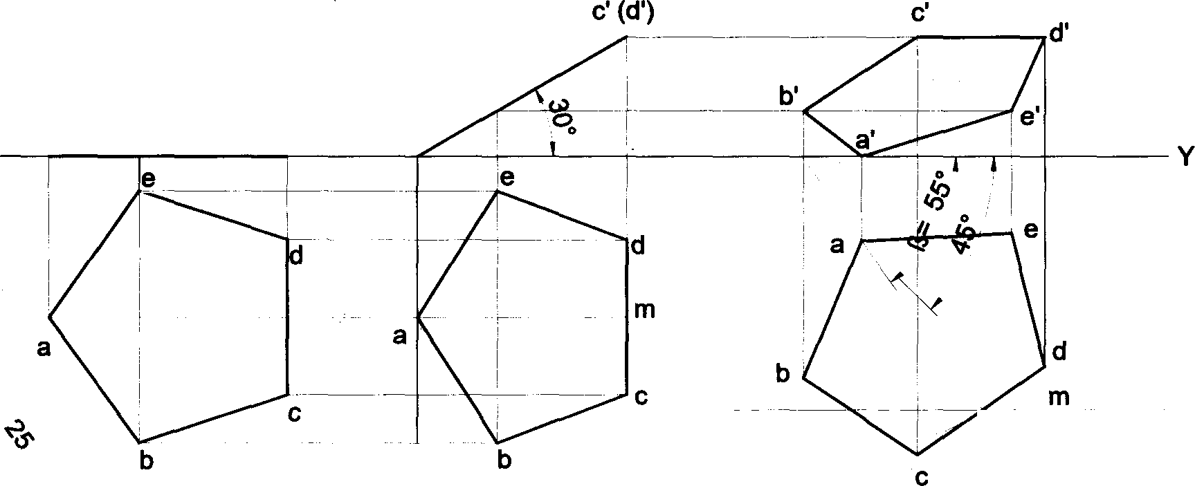

(e') b’

VP a'

HP

(e’) b'

c’ (d')

a'

m‹

Locus of M



X

Problem 24 A pentagonal lamina of sides 25mm is having a side both on HP and VP. The corner opposite to the

side on which it rests is 15mm above HP. Draw the top and front views of the lamina.

##### Solution

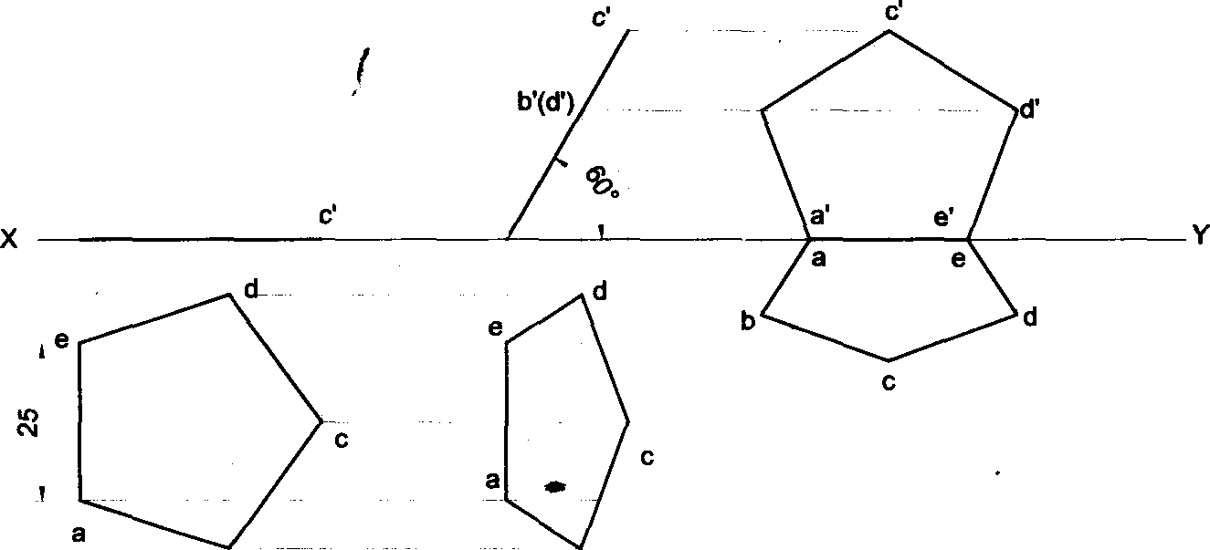

b'

a(e')

b(d')

a'(e')

VP

HP

b b

##### 63



Problem 25 A pentagonal lamina of sides 25mm is having a side both on HP and VP. The surface of the lamina is inclined at an angle of 60• with HP. Draw the top and front views of the lamina.

## Solution

Y

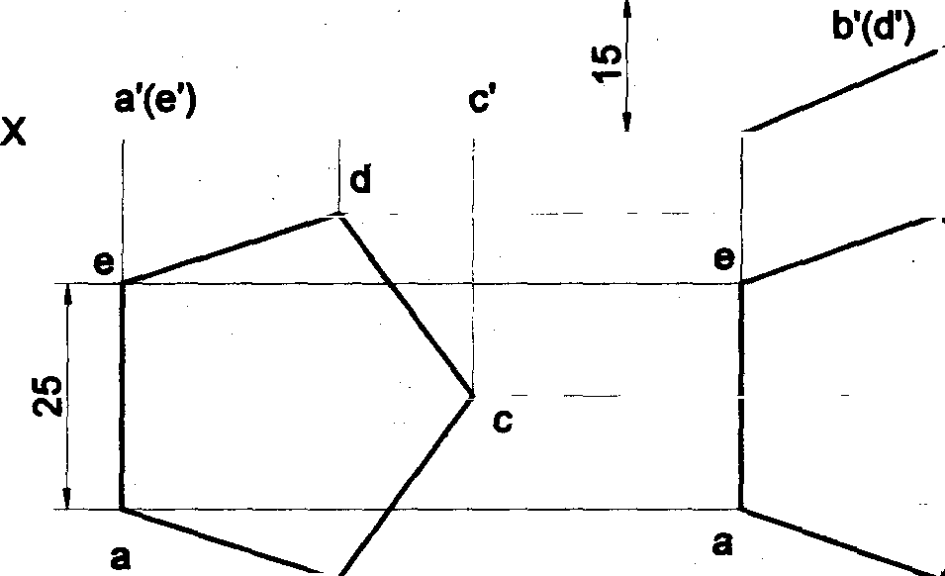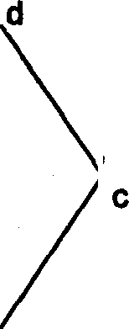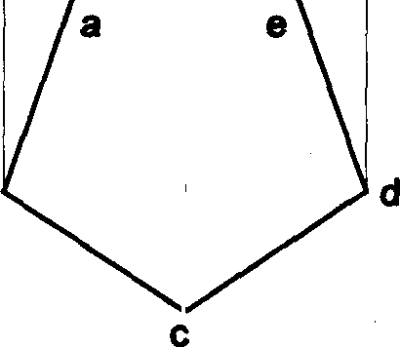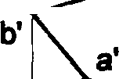

b(d)

VP

HP

b

b b

Problem 26 A regular pentagonal lamina of 25mm side is resting on one of its corners on HP while the side opposite to this comer touches VP. If the lamina makes an angle of 60• with HP and 30° with VP, draw the projections of the lamina.

Solution

c’ (d‘) d’ c'

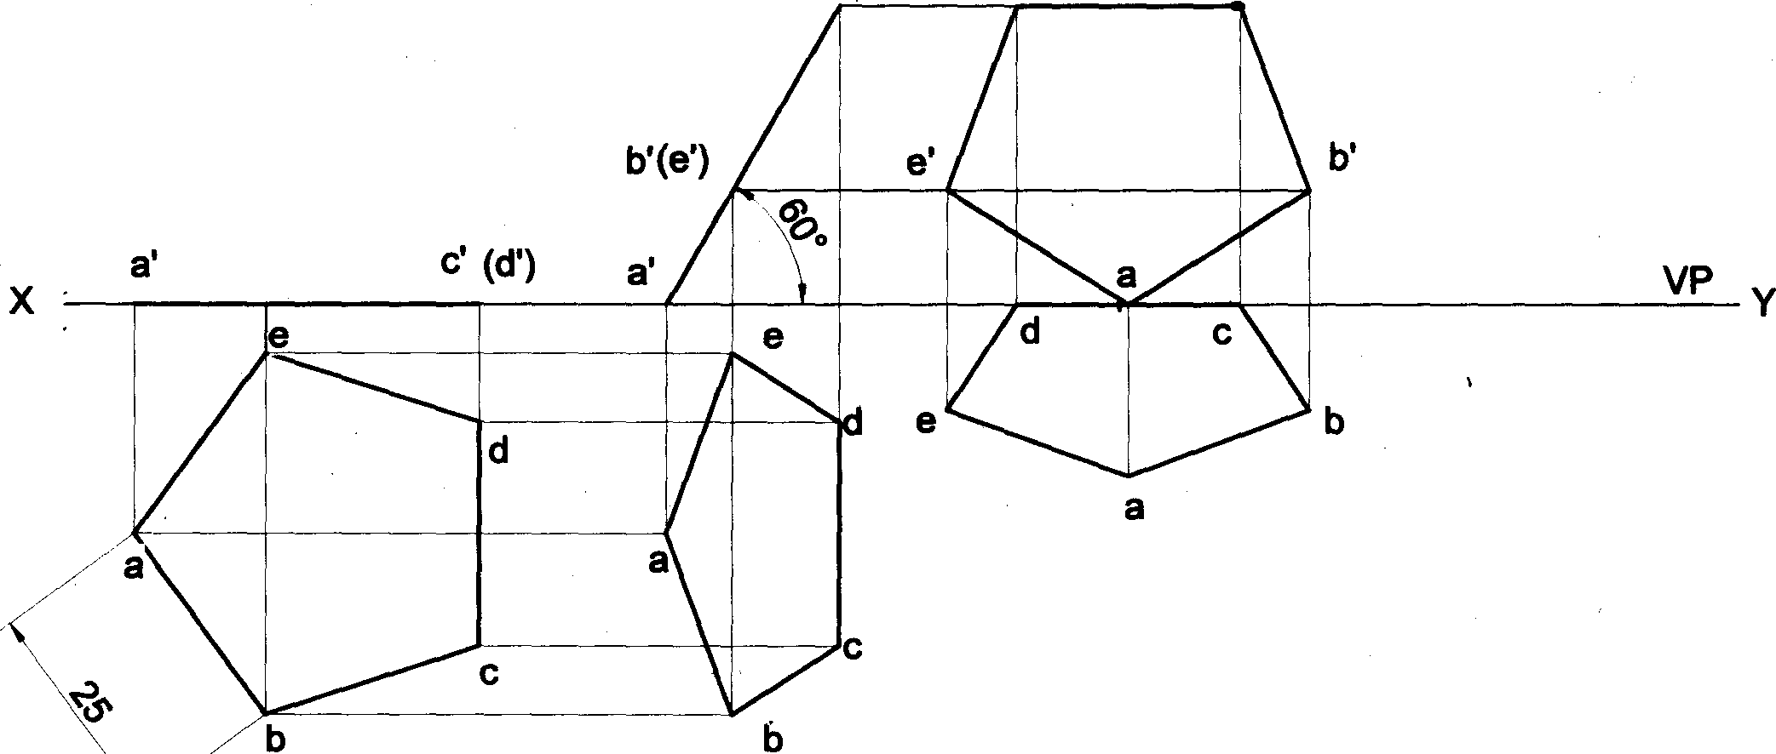

b'(e’)

HP

64

bis

Problem 27 A pentagonal lamina having edges 25mm is placed on one of its corners on HP such that the surface makes an angle 30° with HP and perpendicular bisector of the edge passing through the corner on which the lamina rests appears to be inclined at 30° to VP. Draw the top and front views of the lamina.

Solution

ve a' (e’) b' C' id’) a'

r

HP e

d

(e') b’

e

c(d)

d

b'

a' e'

a

c' d’

Y

e

d

a a

b

b b

side ons

Problem 28 A regular pentagonal lamina of 25mm side is resting on one of its sides on HP while the corner opposite to this side touches VP. If the lamina makes an angle of 60° with HP and 30° with VP, draw the projections of the lamina.

Solution

c’

b’(d')

d’

’( b'(d') a’(e')

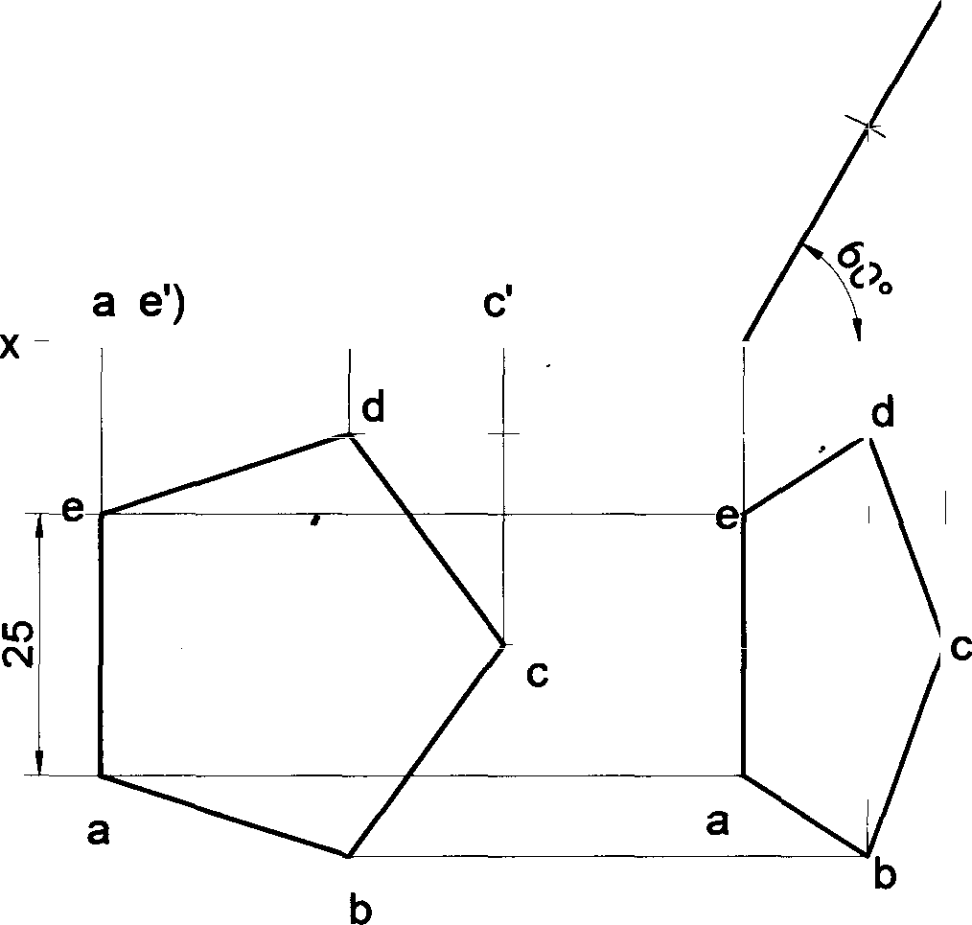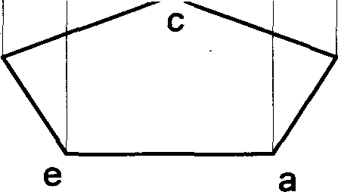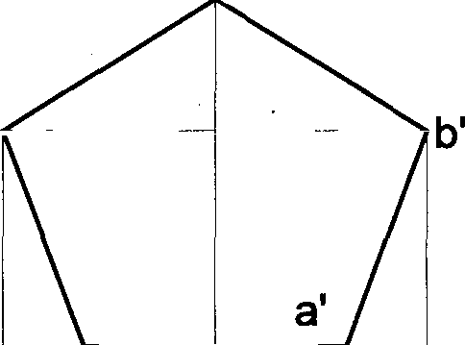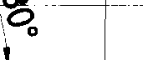

* Y

e' VP

HP Y

d b

65

**Problem 29 A** pentagonal lamina of edges 25mm is resting on VP with one of its sides such that the surface makes an angle of 60° with VP. The edge on which it rests is inclined at 45° to HP. Draw its projections.

###### Solution

d’

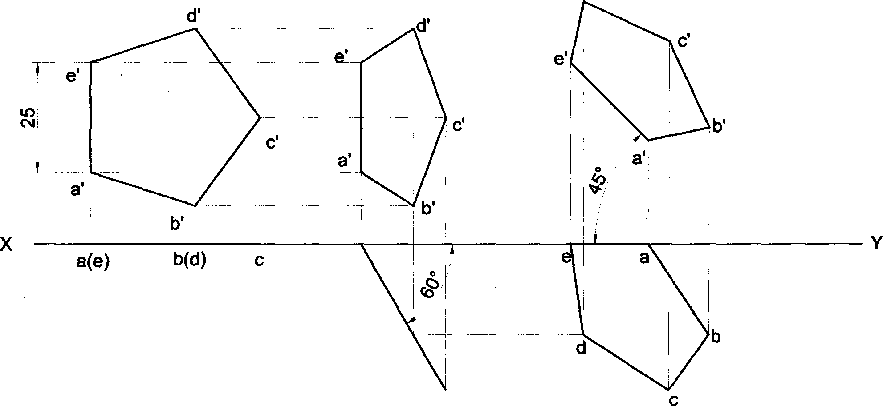

a(e)

VP HP

b(d)

**Problem 30 A** pentagonal lamina having edges 25mm is placed on one of its corners on VP such that the surface makes an angle 30° with VP and perpendicular bisector of the edge passing through the corner on which the lamina rests appears to be inclined at 30° to HP. Draw the top and front views of the lamina.

###### Solution

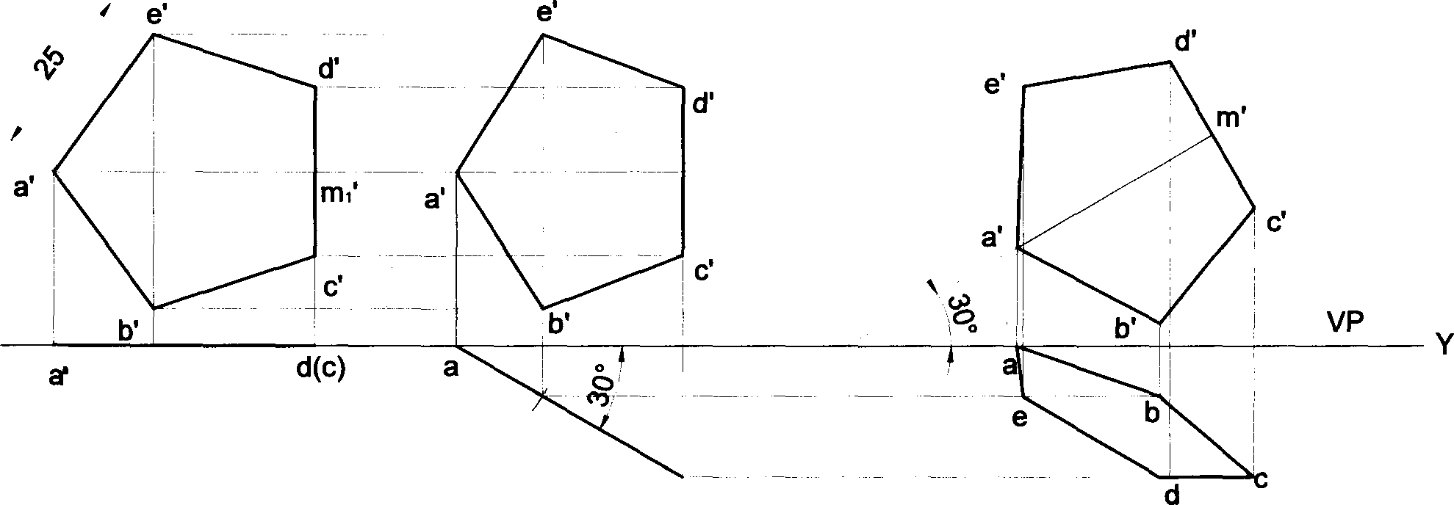

e(b)

HP

e(b)

e(b)

X

66

Problem 31 A pentagonal lamina having edges 25mm is placed on one of its corners on VP such that the surface makes an angle 30° with VP and perpendicular bisector of the edge passing through the corner on which the lamina rests is inclined at 45° to HP. Draw the top and front views of the lamina.

Solution

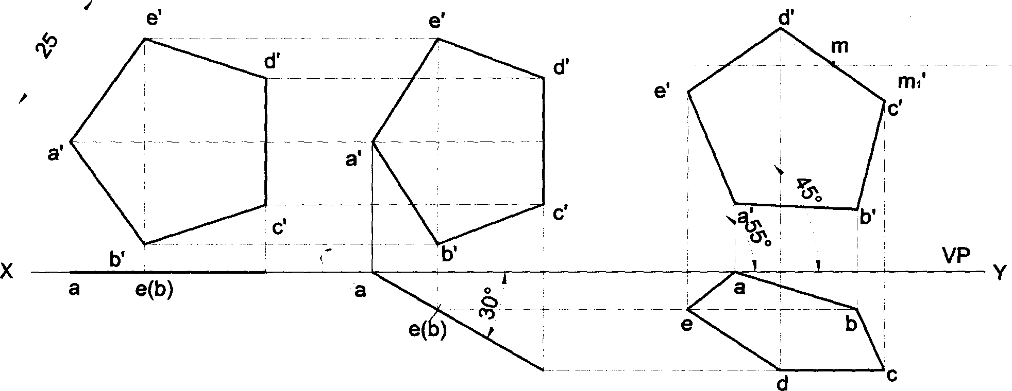

Locus of M

d(c)

HP

d(c)

Problem 32 A hexagonal lamina of 30mm sides rests on HP with one of its corners touching VP and surface inclined at 45° to it. One of its edges is inclined to HP at 30°. Draw the front and top views of the lamina in its final position.

Solution

30 _

“r e’

e' e’

a' d'

b'



a’

a

1. f

d’

b’ c’



d'

a’ Locus of



C'

b' VP

b HP

f

a (b) f

1. e d

(c) e e

d d



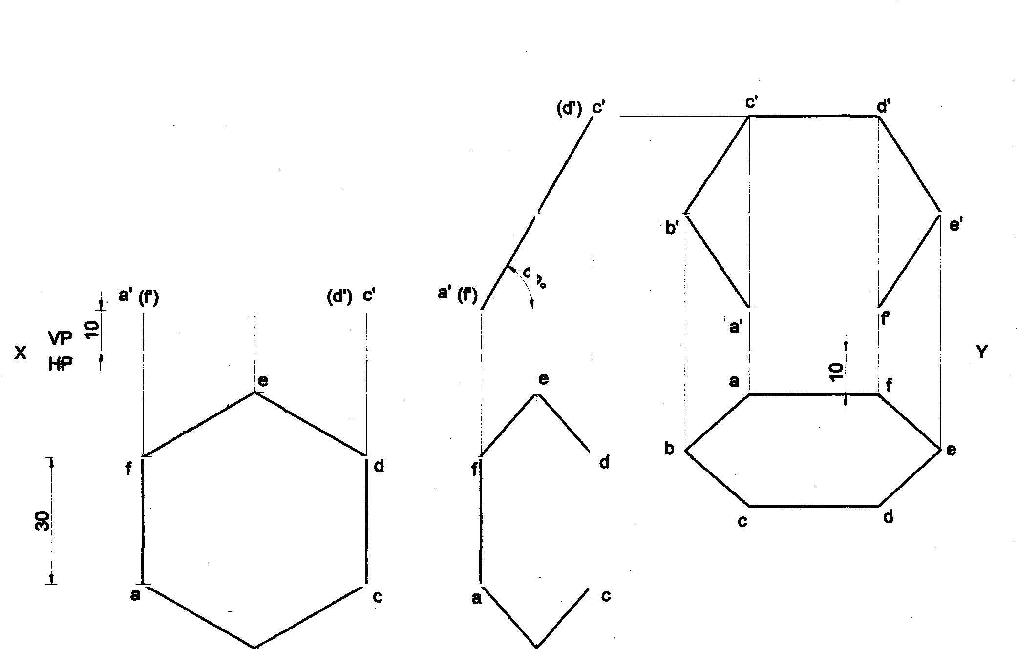

Problem 33 Draw the top and front views of a hexagonal lamina of 30mm sides having two of its edges parallel both vertical and horizontal planes and one of its edges is 10mm from each of the ptanes of projection. The surface of the lamina is inclined at an angle of 60• to the HP.

Solution

(e') b’

(e’) b’

b

b

Problem 34 A regular hexagonal lamina of sides 30mm is lying in such a way that one of its sides touches both the reference planes. If the lamina makes 60• with HP, draw the projections of the lamina.

Solution X,

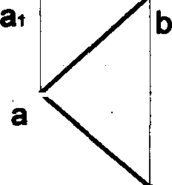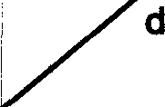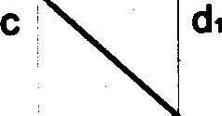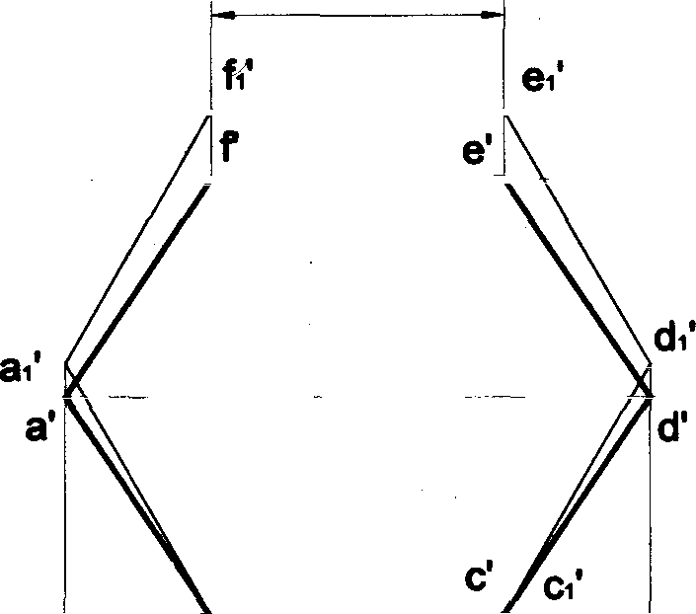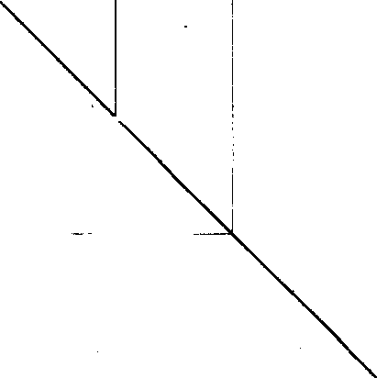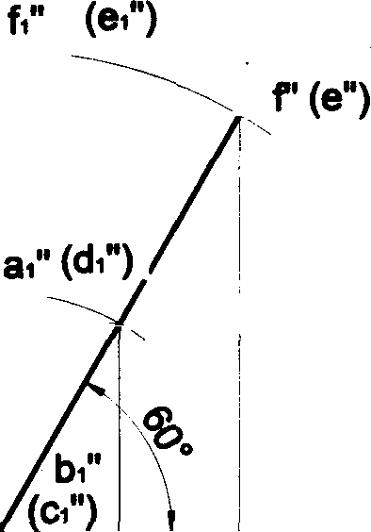

30

a'(d")

b ' b’ VP

HP

f e

68

Problem 35 A regular hexagonal lamina of side 30mm is lying in such a way that one of Its sides touches both the

reference planes. If the side opposite to the side on which it rests is 45mm above HP, draw the rojections of the

lamina.

# Solution

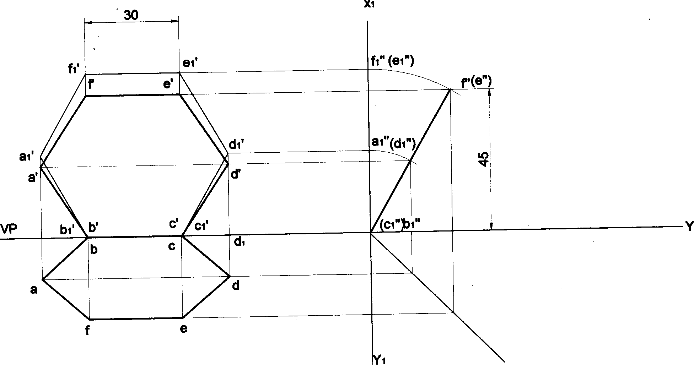

® (d")

HP "

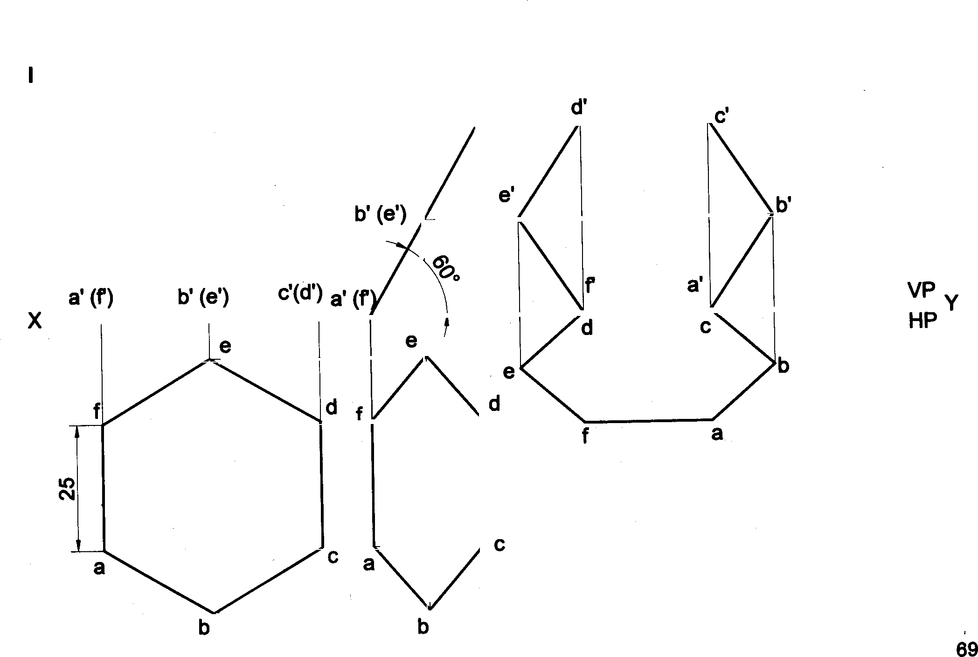

Problem 36 A regular hexagonal lamina of sides 25mm is lying in such a way that one of its

side opposite to the side on which it rests is on VP. If the lamina makes 60° to HP, Draw the projectio

HP while the

na ot the lamina.

So utlon

c'(d')



laminA.

Solution

25 _

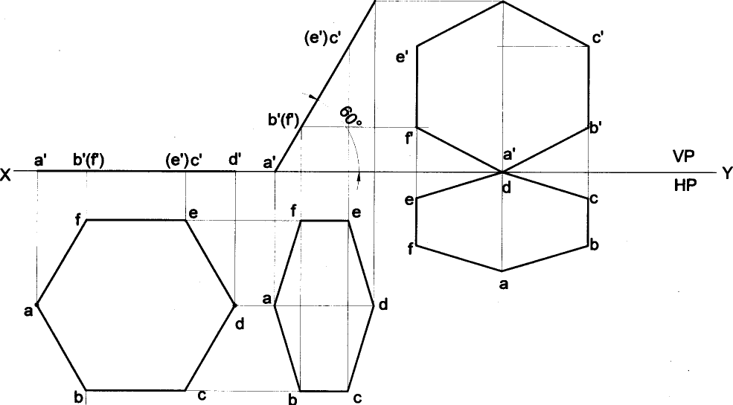



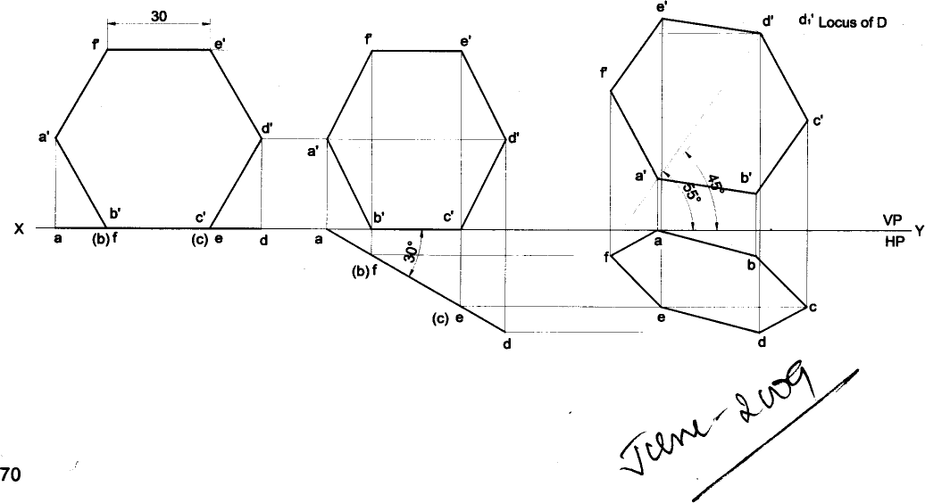

Problem 39 A hexagonal lamina of sides 30mm is resting on HP with one of its corners in VP and its surface inclined at an angle of 30° with VP. The diagonal passing through that corner which is in VP appears to be inclined at 40° to HP. Draw the projections of the lamina.

#### Solution

e'

a (b) f (c) e d

c' VP

HP

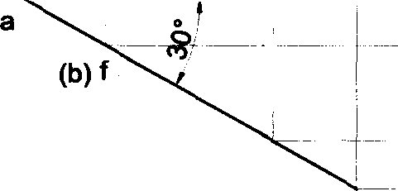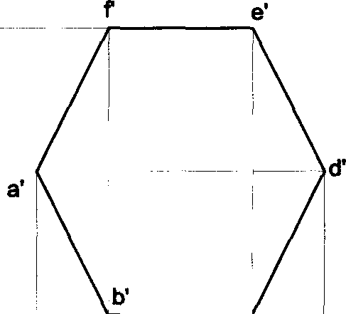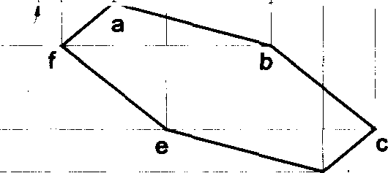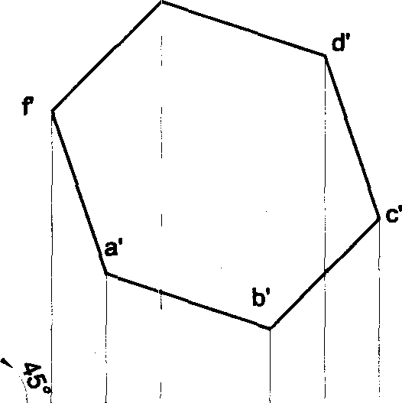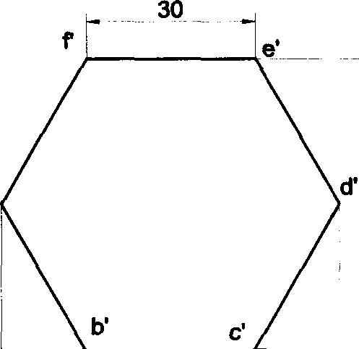

(c) e

d d

Problem 40 A hexagonal lamina of sides 25mm rests on one of its sides on HP. The lamina makes 450 to HP and

the side on which it rests makes 30° to VP. Draw its projections.

##### Solution

c'(d’) d' c'

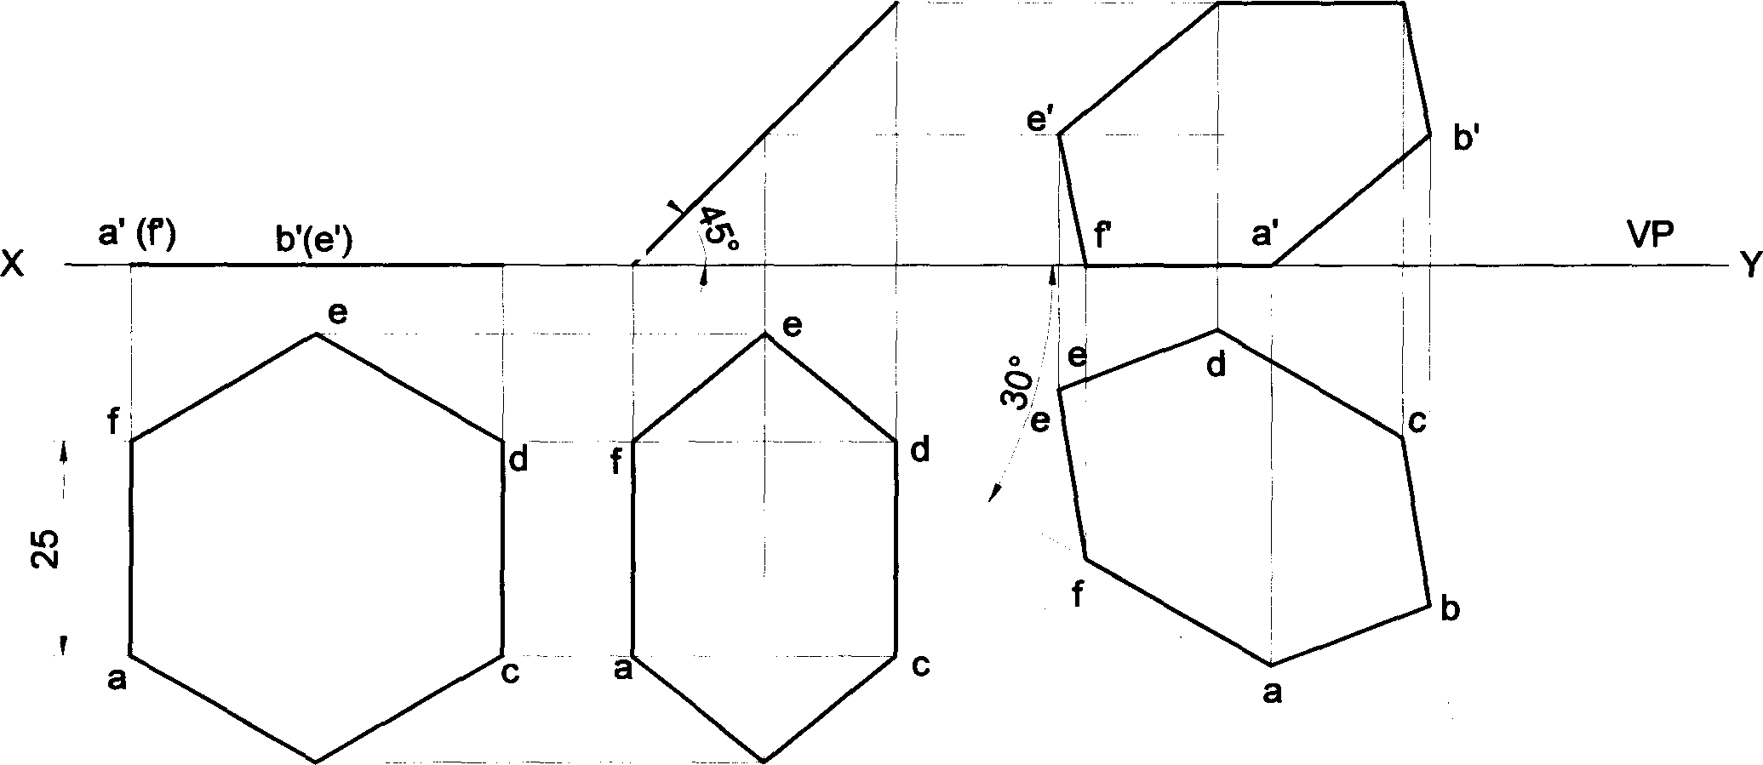

b’(e’)

c’(d’) a' (I),

HP

b b

71

Problem 41 A hexagonal lamina of sides 25mm rests on one of its corners on HP. The lamina makes 45° to HP and the diagonal passing through the corner on which it rests is inclined at 30° to VP. Draw its projections.

Solution

d’ d’

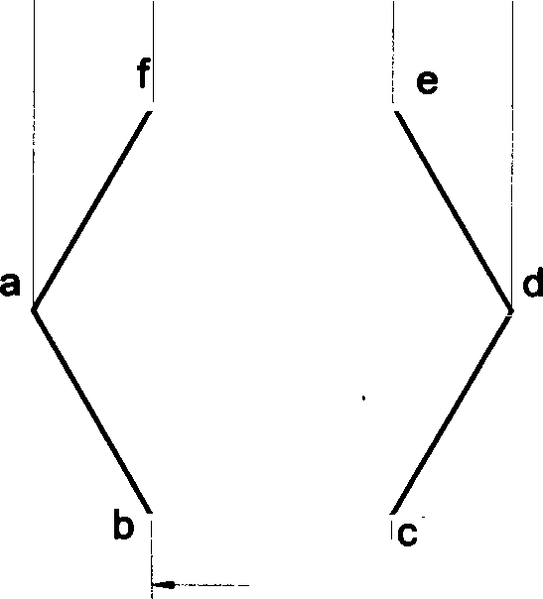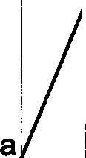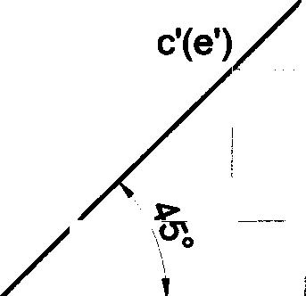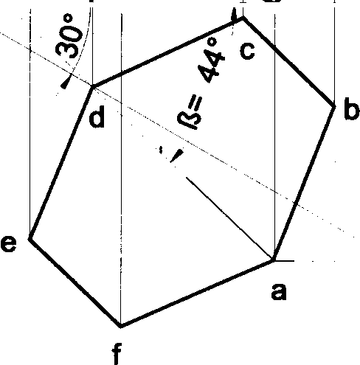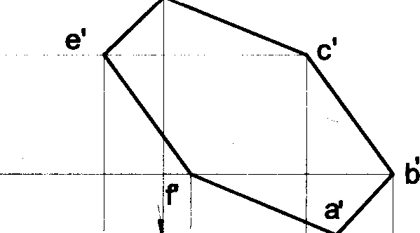

b'(f'

a’ b’(f')

c'(e’) d’

a'

VP

Y

HP

f

d

a1 Locus of A

x

Problem 42 A hexagonal lamina of sides 25mm rests on one of its corners on HP. The lamina makes 45° to HP and the diagonal passing through the corner on which it rests appears to be inclined at 30° to VP. Draw its projections. **Solution**

x Y

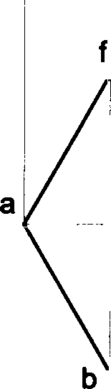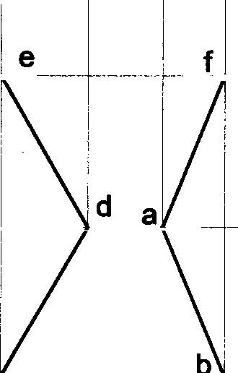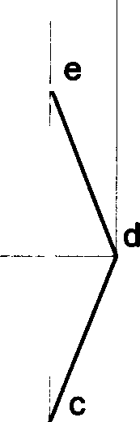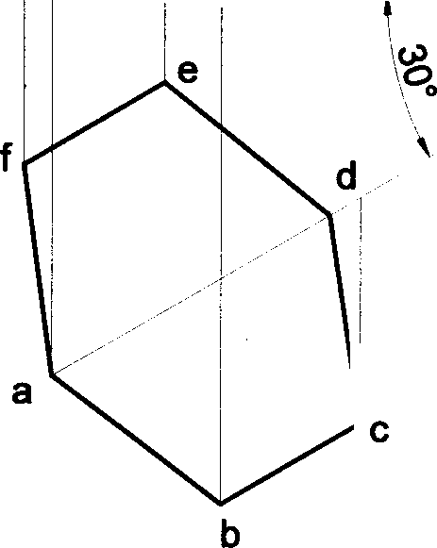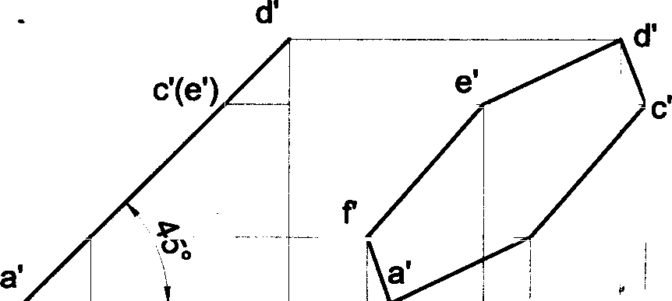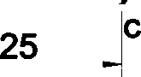

b’(f')

a' b'(f')

c’(e’)

d’

b'

VP

HP

72

**Problem 43 A** hexagonal lamina of sides 25mm rests on one of its sides on VP. The lamina makes 45° to VP and the

side on which it rests makes 45° to HP. Draw its projections.

**Solution**

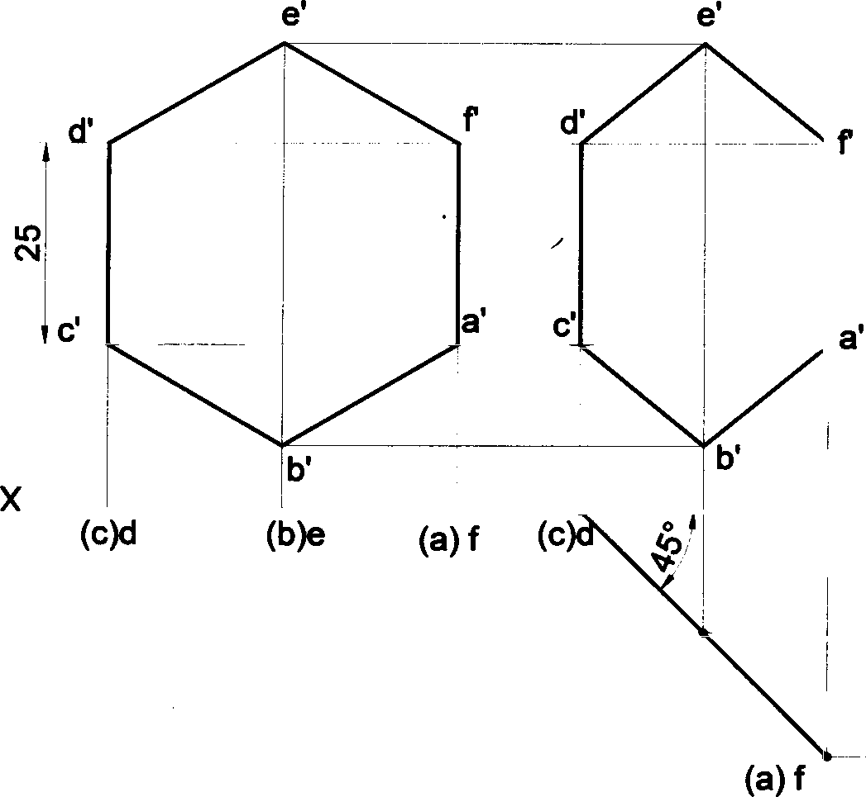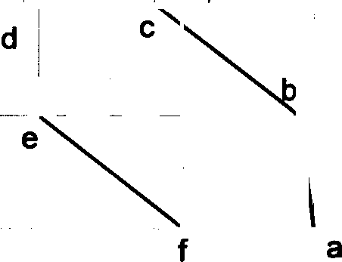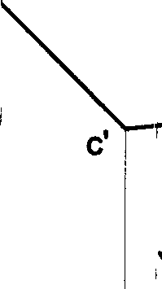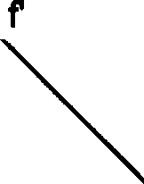

e’

a'

d’

VP

HP

(b}e

**Problem 44 A** hexagonal lamina of sides 25mm rests on one of its sides on VP. The side opposite to the side on which it rests is 30mm infront of VP & the side on which it rests makes 45• to HP. Draw its projections. Also determine the inclination of the lamina with the reference plane.

###### Solution

Y

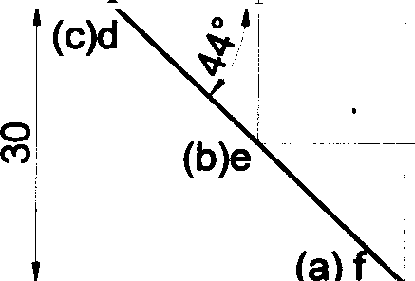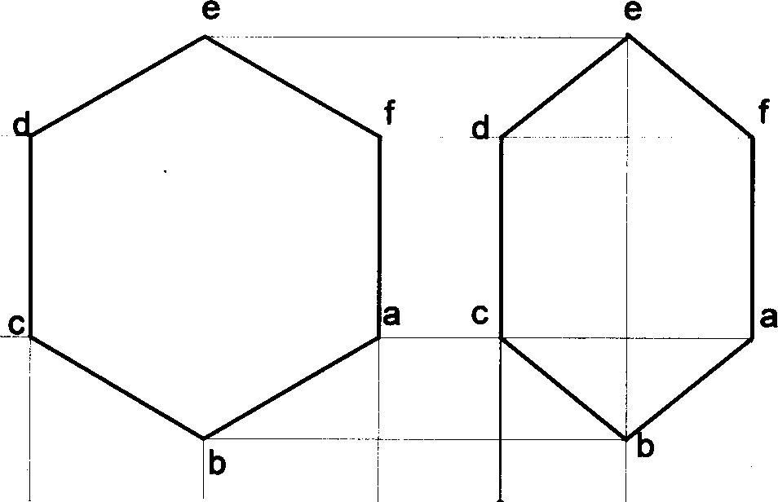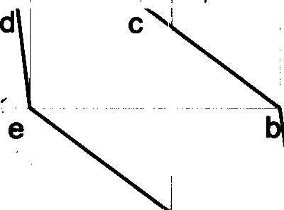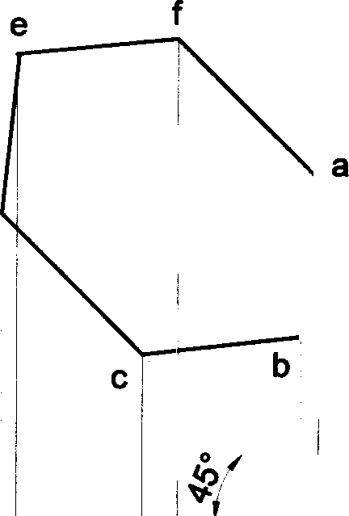

d

(c}d

(b)e (a) f

VP

HP

f a

73

**Problem 45 A** hexagonal lamina of sides 25mm rests on one of its corners on HP. The corner opposite to the corner on which it rests is 35mm above HP and the diagonal passing through the corner on which it rests is inclined at 300 to VP. Draw its projections. Find the inclination of the surface with HP.

**Solution**

d' d’

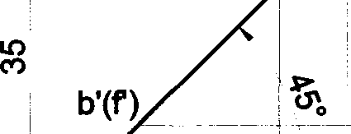c'(e') e'

x

a

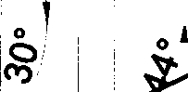

a’ b’(I)

c'(e') d’ , a'

i

a’

VP

HP

f, e

f

e

d

b

25 ~~-~~ c

b

d a'



- - d e



a a1 Locus of A

**Problem 46** Draw the projections of a circular plate of negligible thickness of 50mm diameter resting on HP on a point A on the circumference, with its plane inclined at 45° to HP and the top view of the diameter passing through the resting point makes 60° with VP.

**Solution**



d'(I) d'

VP a' b'(h') c'(g') d'(f') e' HP

b'(h')

a'

g' c’

h’ a’ b

g ’ e

h f

f

a - e

B’ • a

b b d

d • "

h



a

b

74

Problem 47 A circular lamina of 50mm diameter is standing with one of iB points on the rim on HP and the lamina inclined at 45° to HP. The diameter at right angles to the diameter which is passing through the point on which the lamina rests is parallel to VP. Draw ita projections.

## Solution

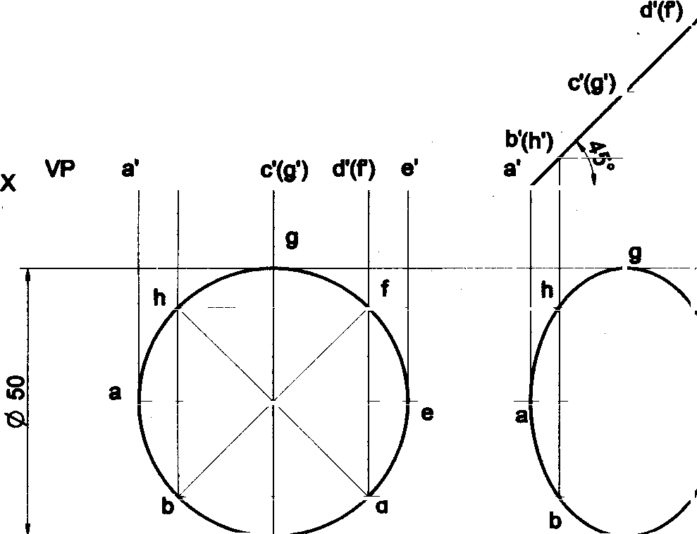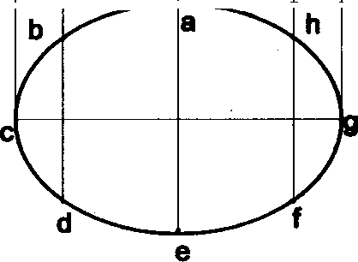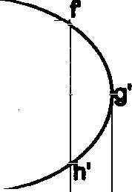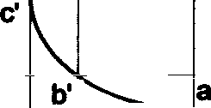

e’

b'(h’)

HP

f

Problem 48 A circular lamina of 50mm diameter rests on HP such that one of its diameters is inclined at 30° to VP

and 45° to HP. Draw its top and front views in this position.

#### Solution

d’(F) e'

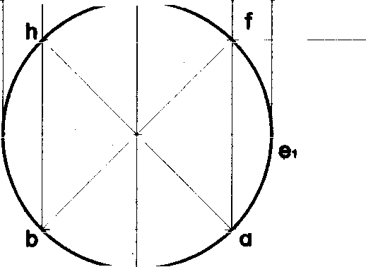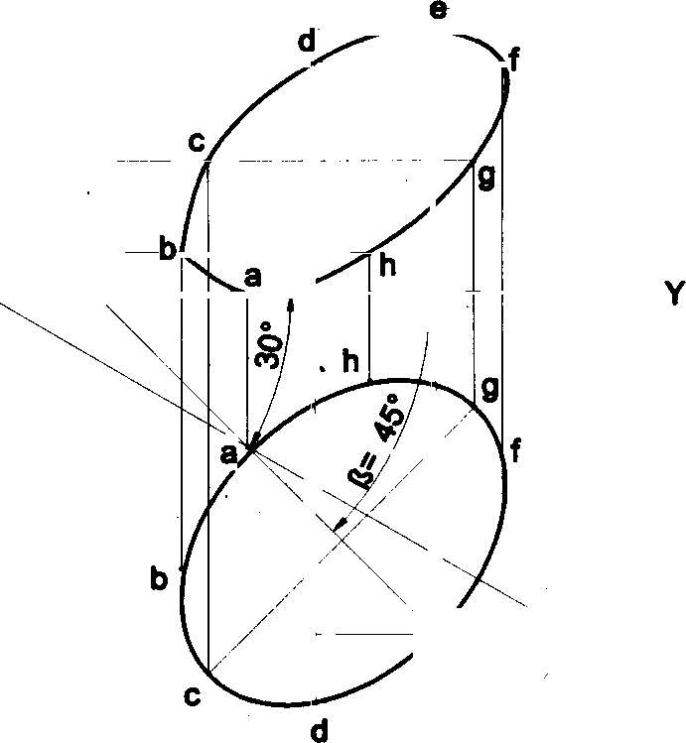

VP a' b’(h') (g') d’(I) e’

a

b'(h’) _

a' %

e” Looks of E

d

” c

75

Problem 49 A circular lamina inclined to the VP appears in the front view as an ellipse of major axis 30mm and minor axis 15mm. The major axis is parallel to both HP and VP. One end of the minor axis is in both the HP and VP. Draw the projections of the lamina and determine the inclination of the lamina with the VP.

Solution

#### Y

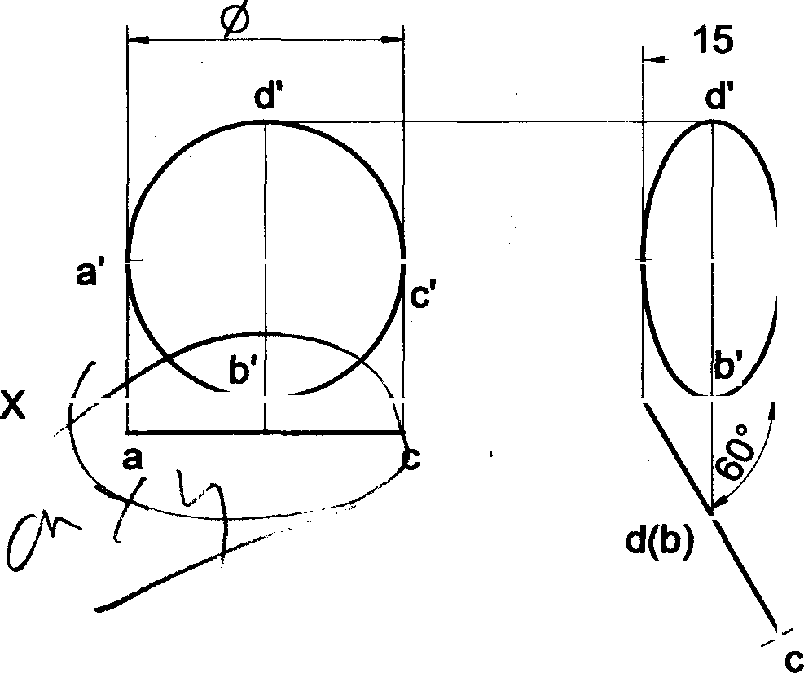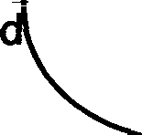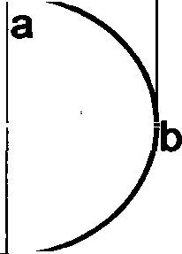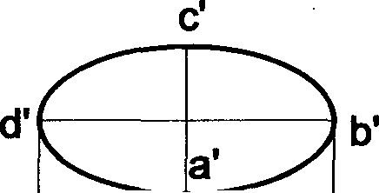

30

a’

c’

a

d(b)

VP

HP

Problem 50 A circular lamina of 30mm diameter rests on VP such 4hat one of its diameters is inclined at 30° to VP and 45• to HP. Draw its top and front views in this position.

Solution

X

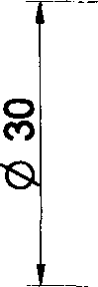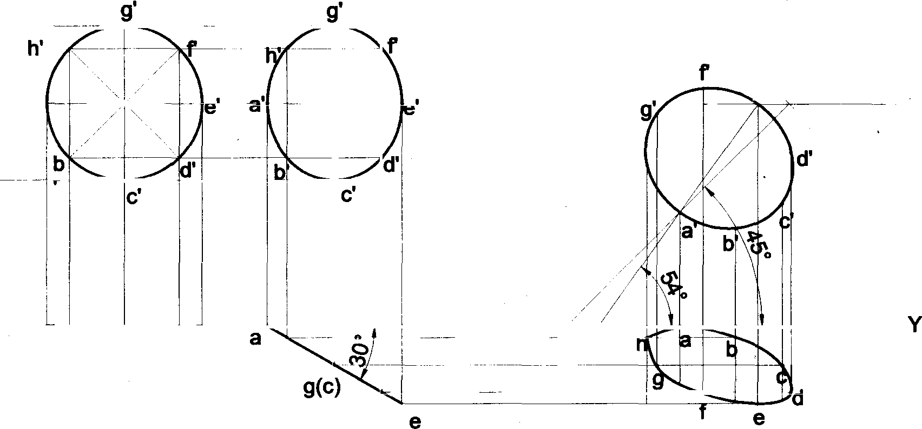

e" e’‹

a’

Locus of E

h’

VP

HP

a h(b) g(c) f(d) e

h(b)

f(d)

76